**Internet of things-**

The Internet of things (IoT) is the network of physical devices, vehicles, home

appliances, and other items embedded with electronics, software, sensors,

actuators, and network connectivity which enable these objects to connect and

exchange data.

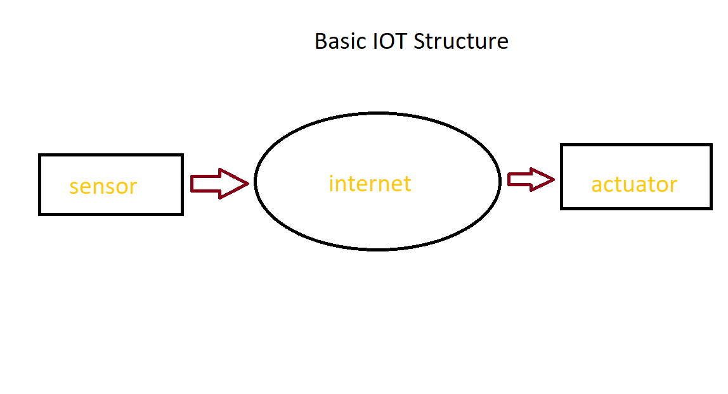

**IOT Controlled Robot Car -**

It is a application of Internet of Things in which controlling of the car is done automatically by using various Internet based control techniques. In this project we are controlling car using Web Page Dashboard and Google Assistant.

To implement this we need:-

1.A Internet Connected MCU connected to Appliances.

2.A Server

3.A Internet Access Device to interact with with Server and a Recent Android Device .

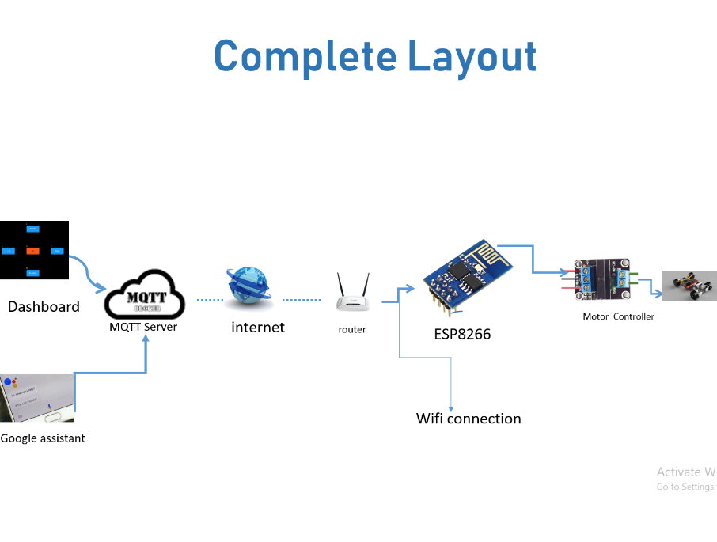

Fig No. 1